AI-Powered Smart Acoustic Monitoring with Multiple Entries Alarm Detection for Low Cost Home Security Systems

Musunuru Rama Pushpalatha
Department of CSE: CSE(AIML)
Velagapudi Ramakrishna Siddhartha Engineering College
Vijayawada, A.P, India
pushpalathamusunuru9@gmail.com
Noshma Chowdary Uppuluri
Department of CSE: CSE(AIML)
Velagapudi Ramakrishna Siddhartha Engineering College
Vijayawada, A.P, India
noshmauppuluri@gmail.com
Pothuri Surendra Varma
Department of CSE: CSE(AIML)
Siddhartha Academy of Higher Education
Deemed To Be University
Vijayawada, A.P, India
suren548@gmail.com

Abstract – An Acoustic-based home security system offers a privacy-safe alternative to traditional video systems, which often use expensive hardware and raise monitoring concerns. This work presents a deep-learning–assisted sound alert detection system that can identify emergency sounds in real time using only a microphone and a software interface. The detection system preprocesses incoming audio, extracts Log-spectrogram features, and classifies them using a trained Convolutional Neural Network (CNN) into alert and non-alert label. In addition to achieving high classification accuracy, the system incorporates a real-time monitoring dashboard that enables users to control listening behaviour. A scheduling module enables alerts to be triggered only during user-defined time periods. It also includes a master alert switch and an email notification toggle to minimize disruptions while preserving logging and oversight. Experimental evaluation demonstrates that the proposed system effectively distinguishes emergency alert sounds from common ambient noise, providing a low-cost, scalable, and user-configurable solution for sound-based home security.
Keywords: Acoustic monitoring, Alarm detection, Multiple entry surveillance, Home security, Real-time CNN sound classification
I. INTRODUCTION
Acoustic monitoring is now an effective and privacy-compliant monitoring alternative to traditional monitoring technologies. Unlike visual approaches which include cameras and continuous video monitoring, acoustic approaches exclusively monitor the environment by analyzing sound patterns to recognize abnormal or emergency events. This acoustic analysis is inherently more secure and less intrusive. Environmental sounds can detect underlying factors that may indicate a violation of safety and security, including sounds from magnetic-sensor buzzer, alarms indicating door tampering, and emergency alert tones. Recent progress in deep learning, audio preprocessing, and real-time signal classification has enabled more sophisticated approaches to sound recognition, moving beyond traditional amplitude threshold methods. [1] [3] This study presents a software-based real-time acoustic alert detection system, which uses a Convolutional Neural Network (CNN) to classify a live audio signal as either alert or non-alert. [3] The incoming signal is simultaneously classified by a trained CNN model through a continuously performing Log-spectrogram feature extraction technique to afford fast detection of alert sounds.[11] The system is additionally integrated into a graphical interface that allows for monitoring, scheduling, and automated notifications in real time, making it a practical sound-driven alert security system. [3]

A. Motivation
Home security typically uses CCTV cameras, and motion detection systems like passive infrared (PIR) based motion sensors. [1] While both are effective solutions, they have many limitations. Cameras are often privacy invasive, require some kind of network storage, and have expensive installation cost. Motion sensors are also limited because they may fail to detect urgent event sounds, such as magnetic-sensor buzzers, fire alarms, or smoke alerts. In reality, urgent situations are often first flagged acoustically which requires immediate user attention. Therefore, sound-based monitoring of home security is increasingly viewed as practicable and privacy-preserving. As a result, a real-time deep learning–enabled acoustic alert system to detect critical sounds and provide alerts to the user was developed.

B. Problem Statement
There is a need for a software-based system that continuously monitors environmental acoustic signals and identifies critical alert sounds in real time. The issue is to design a solution that can extract relevant audio features with automatic detection, classification through a deep learning model, and automatically initiate notifications with no user input at all. [1] The aim of this work is to develop a real-time acoustic alert detection system that incorporates a trained Convolutional Neural Network (CNN) to classify alert and non-alert events from audio recordings. [3] The main problem being solved is the ability to design reliable,user-configurable software for real-time recognition and notifications of alert sounds. [3]

D. Contributions of the Work
This work presents a comprehensive real-time acoustic event detection system with several key contributions. It introduces a deep learning–based classification approach using log-spectrograms and CNN to effectively distinguish between alert and non-alert sounds. It features a real-time monitoring dashboard that visualizes model predictions, confidence scores, and event logs, enabling intuitive system oversight. A functional alert scheduling module is integrated, offering calendar-based configuration with daily and weekly recurrence options. The system incorporates an automated email notification mechanism via the Gmail API, which is selectively triggered for high-confidence alerts occurring within scheduled time windows.

II. LITERATURE SURVEY

A. Existing Solutions
To improve smart home security by identifying life-threatening or unusual sounds in real-time, R. Alajmi et al. [1] developed a mobile robot-based system using a Raspberry Pi to capture audio signals throughout the smart home and a CNN to identify life-threatening events like glass breaking, gunshots, and baby crying, with notifications sent via SMS and other notification methods for the deaf and hearing-impaired. To improve smart living by identifying unattended acoustic events and preventing accidents, S. Pandya et al. [2] developed a system that integrated Local Binary Pattern (LBP) feature extraction with an LSTM-CNN model to identify environmental sounds from ESC-50 and unknown-2000 datasets, with superior performance in noisy conditions compared to conventional classifiers.For improving home safety using audio-based IoT monitoring, S. K. Shah et al. [3] proposed a system that continuously records audio, breaks it into short segments, and uses both shallow and deep learning models, with CNNs reporting the highest accuracy. For a study on deep learning models for audio signal classification, K. Zaman et al. [4] reviewed CNNs, RNNs, autoencoders, Transformers, and combined models, focusing on the application of spectrograms, MFCCs, and wavelet transforms, while a similar discussion on smart home security applications was offered by M. D. G. Dacer et al. [5], focusing on audio-based surveillance systems as an additional functionality to visual systems.For improving the security and privacy of smart homes at entry points, N. Saxena [6] introduced a multimodal approach based on neural networks for real-time facial recognition and speech authentication to identify unauthorized access. For large-scale audio classification, S. Hershey et al. [7] used deep CNN models like AlexNet, VGG, Inception, and ResNet on massive audio datasets, producing transferable embeddings that boosted the performance of acoustic event detection. For precise classification of gunshot audio for public safety, P. Doungpaisan et al. [8] transformed time-frequency audio features to RGB spectrogram images and fine-tuned pre-trained CNN models like ResNet and Inception to identify spectral-temporal features. To overcome the challenges of small labeled datasets and class imbalance, Y. Sun et al. [10] introduced an Automated Audio Augmentation method that optimized waveform and spectrogram-level augmentation strategies using Bayesian search, while J. Salamon et al. [11] showed that deep CNNs with audio data augmentation can substantially boost the accuracy of environmental sound classification.To address the issue of the absence of benchmark datasets, K. J. Piczak [12] presented a publicly available environmental sound dataset and compared machine performance with human accuracy using features like MFCC and zero-crossing rate. To identify abnormal machine sounds based on normal audio data alone, K. Morita et al. [13] presented a self-supervised CNN for identifying abnormal features. For the identification of emotionally significant sound events in smart city and residential settings, A. Mukhamadiyev et al. [14] presented an ensemble CRNN that incorporates convolutional and bidirectional recurrent layers to capture spatial and temporal audio features.To improve the performance of environmental sound classification, Y. Su et al. [15] integrated several auditory features with a CNN and Dempster-Shafer evidence theory for decision fusion at the feature level, and Z. Fang et al. [16] designed a resource-adaptive CNN to improve efficiency for embedded systems. To compare transfer learning approaches, E. Tsalera et al. [17] fine-tuned pre-trained CNNs on sound classification datasets and examined the effect of training parameters on accuracy and efficiencywhereas Z. Mushtaq et al. [18] investigated deep CNN architectures with regularization and data augmentation techniques using Mel spectrogram, MFCC, and Log-Mel features. Finally, the CNN-based spectrogram learning approach was successfully utilized for speech and audio authentication by H. Boulal et al. [19], who designed an Amazigh digit recognition system, and A. Ustubioglu et al. [20], who proposed a CNN-based method for audio copy-move forgery detection using Mel spectrogram images.B.
Challenges in Existing Literature
Many use heavy or multiple stage processing, creating latency and computing demand that would not be appropriate for low-power or edge devices. Furthermore, a number of the systems suffer from a limited number of event categories, and miss the opportunity to serve the most common household alerts that would include a fire alarm and door-sensor buzzers. Noise robustness will still be a significant drawback. Some proposals rely on cloud computing based on a continuous audio stream, resulting in latency, network dependence, and increased power load. Many or most situationally aware systems for real-time detection suggest their sit systems can automatically alert users but this reduces its practical use for emergencies. Weakly supervised approaches are similarly flexible but typically have limitations in performance based on short duration or low-energy sounds, resulting in reduced overall reliability of detection algorithms in home settings.
C. Research Gap
Current acoustic detection systems deal with broad environmental sounds or with specialized hazards, but few systems exist that recognize the specific needs for home-security alerts, such as fire alarms and door-sensor buzzers. Most approaches lack a unified pipeline that incorporates specialized event detection, noise-aware preprocessing, operation in real-time and quick notification all in one system. This work meets this need by providing a lightweight, alert-enabled, on-device acoustic monitoring system that emphasizes fast detection and reliably performs in real-world indoor conditions. A dataset created for this research, low-latency inference with the optimized model, and the integration of an automated email-based alert system support the transformation of general acoustic classification methods into a practical, usable, and deployable tool for home security.

III. PROPOSED METHDOLOGY

The proposed system builds an alerting platform that extends the deep learning classifier into a real-time platform that included continuous audio monitoring, an intelligent decision processor, email automation, and a GUI. The entire system, as proposed, is a software application with no need for new hardware and is ideal for monitoring safety in indoor applications (e.g., elderly care, smart homes, and factory monitoring) . The key functional components consist of real-time audio acquisition, spectral feature extraction and CNN inference, time scheduling-based alert decision mechanism based on confidence, user interface for visual monitoring, logs tracking, and alerts history records.

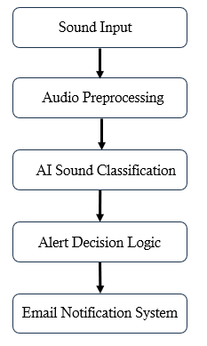

Fig 1 System Workflow
A. Dataset Preparation
A custom dataset was crafted to train a lightweight real-time audio classification model capable of differentiating between alert and non-alert sounds in a smart-home context. The dataset contained two main classes, Alert and Non-Alert, and each class contained 54 unique subcategories for different sound sources. Each subcategory contained 40 audio files, yielding a total dataset of 4320 audio files. Each dataset was provided in a WAV file format and fixed audio lengths of 6 seconds. Audio samples were derived from the ESC50 dataset and added indoor sourced recordings to simulate realistic acoustic conditions. Recordings included a variety of noise sources, including conversation, fan noise, and appliance noise. The dataset was designed to be comprehensive and yet balanced so that the classifier could learn to differentiate emergency sounds from everyday ambient sounds.

B. Data Preprocessing
When the device acquire small segments of audio from the microphone. Each segment of audio is preprocessed in a consistent manner. Specifically, concerning preprocessing resampled to 16 kHz with a mono channel, amplitude normalization and remove silence from audio to minimize unnecessary segments. The preprocessed frame of audio is subsequently transformed to a log-Mel spectrogram that captures the spectral characteristics and time representation of sound.
$$S_{mel}(f,t)=MelFilterBank(∣STFT(l(t))∣^{2})$$
$$LogMel(f,t)=10{log⁡}_{10}(S_{mel}(f,t)+ϵ)$$
where $f$denotes the Mel frequency band index, $t$denotes the time frame index, and $ϵ$is a stabilizing constant.
C. CNN-Based Sound Classification
Customized CNN model is developed for inference use in the real-time monitoring. The CNN model takes the presence of the spectrogram. We used sparse categorical crossentropy for loss function and Adam optimizer with initial lr 1e-3 and ReduceLROnPlateau for optimization.

Provides a distribution of probabilities across the two output classes: Alert and Non-Alert:
$$P(l_{i}∣a)=\frac{e^{a_{i}}}{\sum_{j=1}^{K}{e^{a_{j}}}}$$
The predicted class label is determined by:
$$label=arg⁡\underset{i}{max⁡}P(l_{i}∣a)$$
The confidence level of the prediction is:
$$C=\underset{i}{max⁡}P(l_{i}∣a)$$
A threshold-based strategy is applied to make reliable decisions. Only predictions with $C≥0.90$are treated as true alerts.
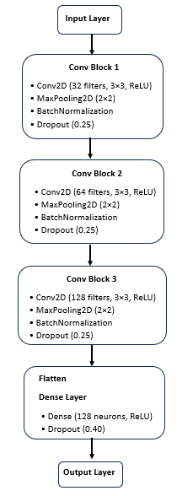

Fig 2 CNN Architecture

D. Graphical User Interface and System Control
The trained CNN model is integrated into the system's Graphical User Interface (GUI) which is created in Python and features three major modules:

Table 1 Modules in System GUI
UI Module | Purpose
Dashboard | Start/Stop listening, live status, last detected event, and real-time log window showing model predictions.
Settings | Email recipient entry, alert scheduling (start/end time), and saving configuration to file.
Alert History | Displays logged alerts including timestamp, prediction label, confidence percentage, and whether an email was successfully sent.

The real-time log window constantly displays system activity including when listening is activated, audio frame captured, model prediction and confidence score and email is sent successfully. All logs are automatically stored in a text file named detections_DD-MM-YYYY.txt for tracking and reproducibility.

E. Scheduling and Alert Control Features
To enhance usability and avoid emails, the interface of the system was enhanced with additional alert-control features to manage when the system is to send out alerts. Alert-controls include:

1. Scheduling feature:
For scheduling the user can customize the duration using calendar for full date-time scheduling rather than just time of day, Daily/Weekly recurrence pattern which is used in alarm systems and provides monitoring options for work hours, weekends, or night hours.

2. Master Alert ON/OFF Switch
A global control switch for turning the full alerting system ON or OFF. When it is OFF listening is stopped, email notifications will not be sent, scheduled routines will go to a paused state; however, the UI and logs will remain visible to the user. In addition to providing the user with their enhanced alerts for current work during testing, it also reduces the risk of spamming their emails while still allowing full user control.

3.“Disable Email Alert” Toggle:
An additional toggle allows the user to disable the email action while still keeping real-time predictions and logs active. This can be useful for an audience during monitoring without sending notifications to them. The last item that was modified is the Alert execution logic.
The alert execution logic was updated as follows:

Alert =
1, if (GlobalSwitch = ON) AND
(EmailToggleEnabled = TRUE) AND
(CurrentDate is within SelectedDateRange) AND
(CurrentDay is in SelectedWeekDays) AND
(CurrentTime is within ScheduledTime)
0, otherwise

These enhancements transform the application into a fully configurable alerting system comparable to professional safety/security software while ensuring that the CNN model inference pipeline remains unchanged.

F. Algorithm Description
Algorithm : Acoustic Alert Detection and Notification
Input : Live audio stream from microphone
Output : Class label (Alert / Non-Alert), confidence score, email alert
1. User clicks "Start Listening"
2. Capture audio frame y(t)
3. Preprocess → convert to log-Mel spectrogram

4. CNN inference → obtain prediction probabilities
5. Determine predicted class and confidence C
6. If (C > Threshold) and (within scheduled time):
Send email notification
Log to history table and store in text file
7. Repeat until user clicks "Stop Listening"
This structure enables autonomous monitoring with operator visibility and minimal human intervention.

IV. RESULTS AND ANALYSIS
The system was evaluated in real-world environments using alert sounds (fire alarms, magnetic sensor, sirens) and non-alert sounds (speech, fan noise, household noises). Using a graphical user interface (GUI) for demonstration purposes allowed both qualitative and quantitative evaluations.

A. Model Performance

Table 2 Various Model’s Performance Metrics
Model | Accuracy | Precision | Recall | F1-Score
CNN | 98.61% | 98.63% | 98.61% | 98.61%
Random Forest | 99.59% | 99% | 98.61% | 98.61%
SVM | 99.24% | 99% | 100% | 99%
XGBoost | 99.71% | 99% | 100% | 99%
Logistic Regression | 99.18% | 99% | 99% | 99%
KNN | 99.02% | 99.76% | 98.26% | 99.01%

Fig 3 Bar Chart for comparision of various model performances

Although multiple machine-learning and deep-learning models were trained on the curated dataset, only the CNN model provided reliable and consistent performance through its evaluation in a real-world context. While other models achieved high accuracy values on the training and validation data but predicted erratically when evaluated on unseen audio samples. This indicates that these models were overfitting to the training data and were unable to generalize effectively to real-time acoustic variations. In contrast, the CNN model maintained high accuracy, precision, recall, and F1-score performance metrics across all testing scenarios, making it the most appropriate of the assessed models to use in the proposed real-time alert detection system.

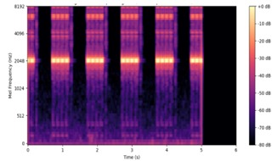
Fig 4 Spectrogram of an Audio Sample
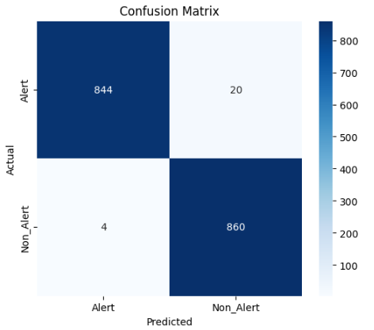

Fig 5 CNN model confusion matrix
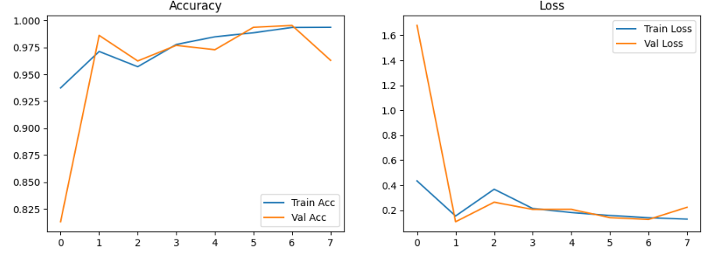
Fig 6 Accuracy and Loss Curves
Fig 5 shows consistent improvement in the CNN model, achieved high accuracy and maintained low loss. This makes it well versed for real-time alert and non-alert sound classification.

B. System Performance
Table 4 Performance Metrics for the System
Parameter | Result
Prediction latency | < 150 ms
Email dispatch time | < 3 seconds
False alert rate | < 5%
GUI responsiveness | Real-time updates with no lag

B. Experimental Results of Real-Time Monitoring
During live testing, the system demonstrates live updates on the dashboard facilitating real-time predictions, confidence scores, messages being logged, automatic creation of an alert in the history table.
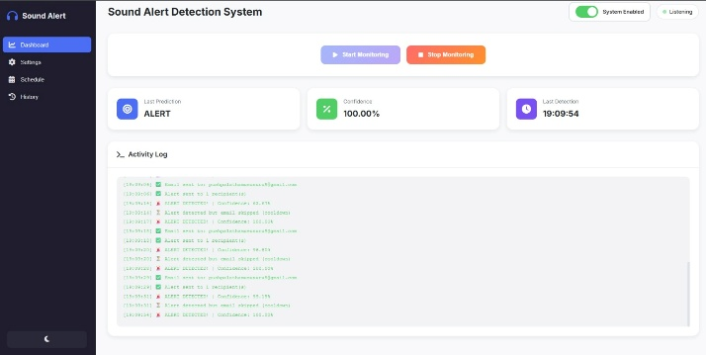
Fig 7 UI of the System

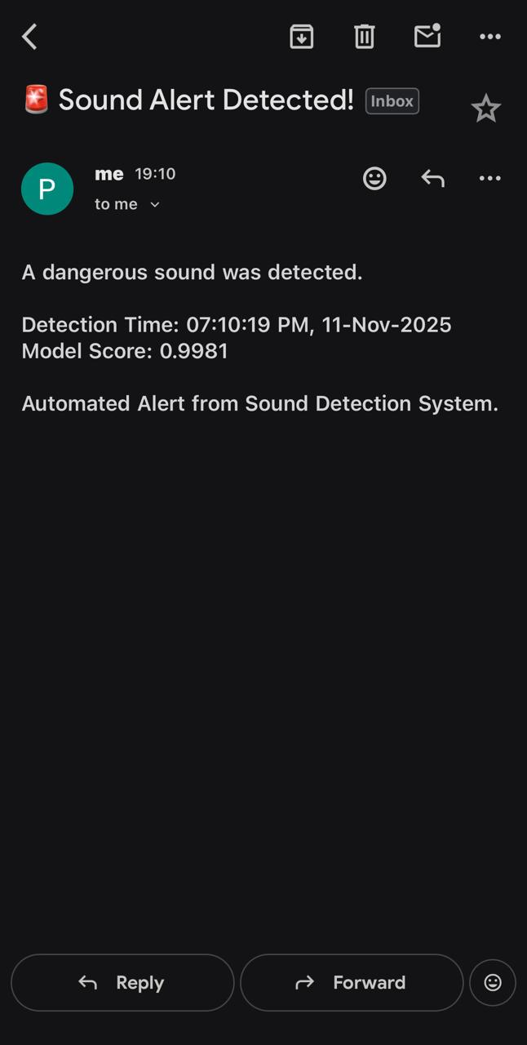

Fig 8 Email Alert Notification

V. CONCLUSION
The system developed combines a deep learning model and user-interactive alerting interface that can monitor sounds of audio and send notifications automatically in real-time. The system accurately categorizes environmental audio into alerts or not alerts based on the Mel-spectrogram feature and uses a trained CNN model, allowing for sound-based recognition without needing specialized hardware or visual monitoring. Further, its scheduling features enable users to determine when the system should operate, and the option for email notifications allows users flexibility in their response to alerts. Our experiments show the system will accurately detect alert sounds and become rapidly notified of alerts via automated email messaging while recording all detected events in the alert history log for tracking purposes. This system combines real-time monitoring, configurability, and automatic alerting, providing a cost-effective, privacy-conscious, and user-friendly solution for home security and indoor safety measures.

REFERENCES

[1] R. Alajmi, N. Alawadhi, Z. Alkandari, T. Alhajri, M. Alkafeef, and I. Boulkaibet, “Deep Learning-Based Audio Classification for Smart Home Security,” in 2025 6th International Conference on Bio-engineering for Smart Technologies .Paris, France, 2025.
[2] S. Pandya and H. Ghayvat, “Ambient acoustic event assistive framework for identification, detection, and recognition of unknown acoustic events of a residence,” Advanced Engineering Informatics, vol. 47, 2021.
[3] S. K. Shah, Z. Tariq, and Y. Lee, “Audio IoT Analytics for Home Automation Safety,” IEEE, 2018.
[4] K. Zaman, M. Sah, C. Direkoglu, and M. Unoki, “A Survey of Audio Classification Using Deep Learning,” IEEE Access, vol. 11, pp. 106620–106649, 2023.
[5] M. D. G. Dacer and J. B. Matias, “Smart Home Security Through Real-Time Audio Event Detection Systems Using CNN,” IEEE, 2025.
[6] N. Saxena, “Smart Home Security Solutions using Facial Authentication and Speech Recognition,” ScienceDirect (Elsevier), 2021.
[7] S. Hershey, S. Chaudhuri, D. P. W. Ellis, J. F. Gemmeke, A. Jansen, and R. C. Moore, “CNN architectures for large-scale audio classification,” IEEE, 2017.
[8] P. Doungpaisan and P. Khunarsa, “Deep spectrogram learning for gunshot classification: A comparative study of CNN architectures and time–frequency representations,” J. Imaging, vol. 11, no. 8, Art. no. 281, 2025, doi: 10.3390/jimaging11080281.
[9] M. K. Z. Bajwa, A. Castiglione, and C. Pero, “Mel Spectrogram-Based CNN Framework for Explainable Audio Deepfake Detection,” in Proc. AINA 2025, Lecture Notes on Data Engineering and Communications Technologies, vol. 252, Springer, Cham, 2025.
[10] Y. Sun, K. Xu, C. Liu, Y. Dou, H. Wang, and B. Ding, “Automated Data Augmentation for Audio Classification,” IEEE/ACM Transactions on Audio, Speech, and Language Processing, vol. 32, pp. 2716–2728, 2024.
[11] J. Salamon and J. P. Bello, “Deep Convolutional Neural Networks and Data Augmentation for Environmental Sound Classification,” IEEE Signal Processing Letters, vol. 24, no. 3, pp. 279–283, 2017.
[12] K. J. Piczak, “ESC: Dataset for Environmental Sound Classification,” in Proc. ACM Multimedia (MM ’15), pp. 1015–1018, 2015.
[13] K. Morita, T. Yano, and K. Q. Tran, “Anomalous sound detection using CNN-based features by self-supervised learning,” Detection and Classification of Acoustic Scenes and Events (DCASE) 2021 Challenge Technical Report, 2021.
[14] A. Mukhamadiyev, I. Khujayarov, D. Nabieva, and J. Cho, “An ensemble of convolutional neural networks for sound event detection,” Mathematics, vol. 13, no. 9, Art. no. 1502, 2025.
[15] Y. Su, K. Zhang, J. Wang, and K. Madani, “Environment sound classification using a two-stream CNN based on decision-level fusion,” Sensors, vol. 19, no. 7, Art. no. 1733, 2019.
[16] Z. Fang, B. Yin, Z. Du, and X. Huang, “Fast environmental sound classification based on resource adaptive convolutional neural network,” Scientific Reports, vol. 12, Art. no. 6599, 2022.
[17] E. Tsalera, A. Papadakis, and M. Samarakou, “Comparison of pre-trained CNNs for audio classification using transfer learning,” J. Sens. Actuator Netw., vol. 10, no. 4, Art. no. 72, 2021.
[18] Z. Mushtaq and S.-F. Su, “Environmental sound classification using a regularized deep convolutional neural network with data augmentation,” Applied Acoustics, vol. 167, Art. no. 107389, 2020.
[19] H. Boulal, M. Hamidi, M. Abarkan, and J. Barkani, “Amazigh CNN speech recognition system based on Mel spectrogram feature extraction method,” Int. J. Speech Technol., vol. 27, pp. 287–296, 2024, doi: 10.1007/s10772-024-10100-0.
[20] A. Ustubioglu, B. Ustubioglu, and G. Ulutas, “Mel spectrogram-based audio forgery detection using CNN,” Signal, Image Video Process., vol. 17, pp. 2211–2219, 2023, doi: 10.1007/s11760-022-02436-4.

